**Bug Reports for Buggy Cars Rating WebApp**

Table of Contents

**1. Visible user details post logout** 3

**2. Home Page Navigation Broken** 4

**3. Pagination is broken** 5

# **1. Visible user details post logout**

Summary:

User details are still visible post logout

Steps to reproduce:

1. Open the Buggy Cars Rating web-app using link: <https://buggy.justtestit.org/>
2. In the Login field at the top of the screen, enter: TestUser99
3. In the Password field at the top of the screen, enter: Password1!
4. Click on the Login button next at the top of the screen
5. Click on the Profile button at the top of the screen
6. Click on the Logout button next to the Profile button
7. Observe that user is logged out, but user details on the Profile page are still visible

What is working:

User is logged out of the application on clicking the Logout button

What is not working

User is not getting redirected away from the Profile page and is still able to see it’s details post logout

Impact:

Privacy issues could arise since sub-sequent users might be able to see current user’s personal details

Priority:

P1

Severity:

Medium

Attachments:

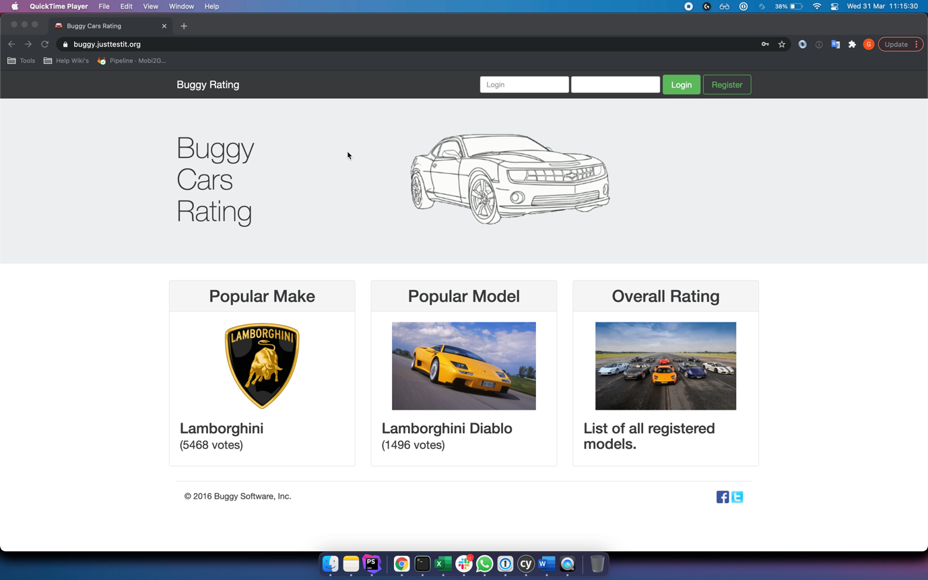Logout_Issue.mov

Testing Details:

Platform: Macintosh Big Sur

Browser: Google Chrome v88.0.4324.192

# **2. Home Page Navigation Broken**

Summary:

User is unable to navigate to Home Page

Steps to reproduce:

1. Open the Buggy Cars Rating web-app using link: <https://buggy.justtestit.org/>
2. Click on the image under the “Popular Make” category to open the category
3. Once the category is open, click on the Buggy Rating logo at the top bar of the application
4. Observe that nothing happens and the link to the home page is displayed in the bottom left corner of the screen as : https://buggy.justtestit.org/broken

What is working:

User is able to get back to the application home page using the back button

What is not working

User is unable to navigate back to the application home page using the application links

Impact:

Un-intuitive and counter-productive customer experience

Priority:

P1

Severity:

Medium

Attachments:

Home_Page_Navigation_Issue.mov

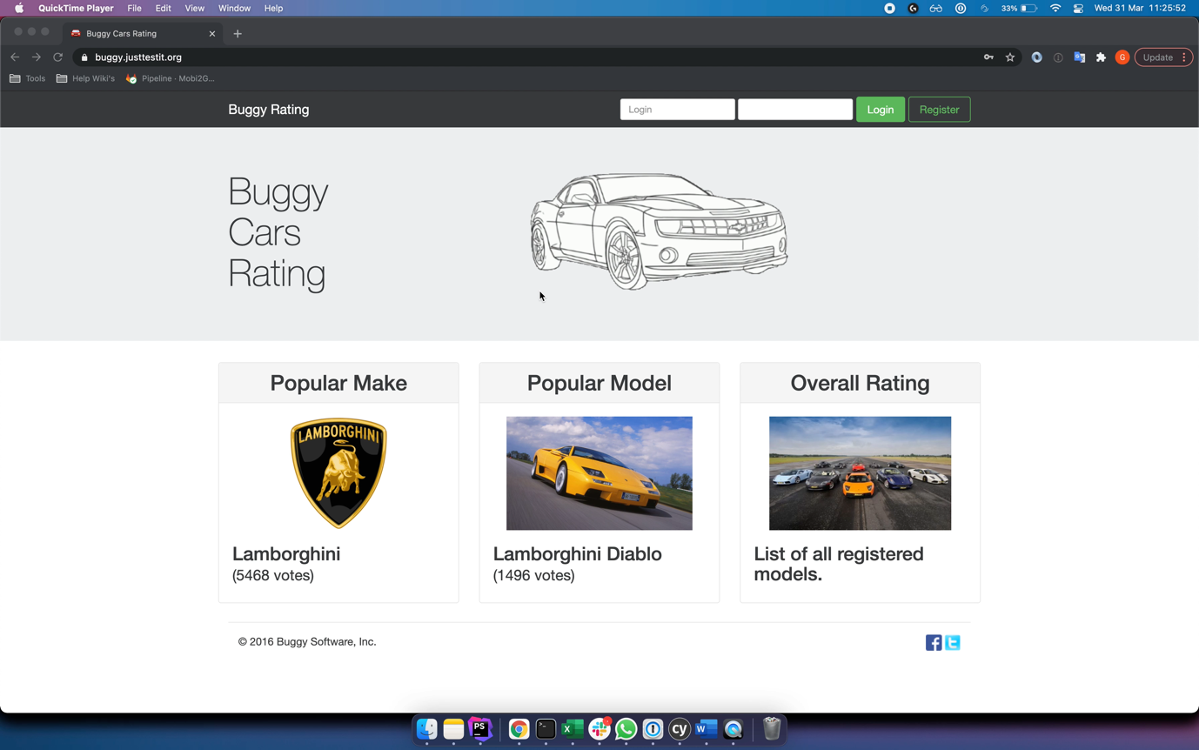

Testing Details:

Platform: Macintosh Big Sur

Browser: Google Chrome v88.0.4324.192

# **3. Pagination is broken**

Summary:

Next page button on the last page is not disabled

Steps to reproduce:

1. Open the Buggy Cars Rating web-app using link: <https://buggy.justtestit.org/>
2. Click on the image under the “Overall Rating” category to open the category
3. Once the category is open, scroll to the bottom of the page and keep clicking the next page button
4. Observe that even after the last page is opened, user is still able to click on the next page button, which should be disabled, to navigate to non-existing pages

What is working:

User is able to use pagination to navigate to valid pages

What is not working

Next page button is not disabled for last page of results

Impact:

Unintuitive customer experience especially for novice users which might lead them to be stuck on a non-existing page

Priority:

P1

Severity:

Medium

Attachments:

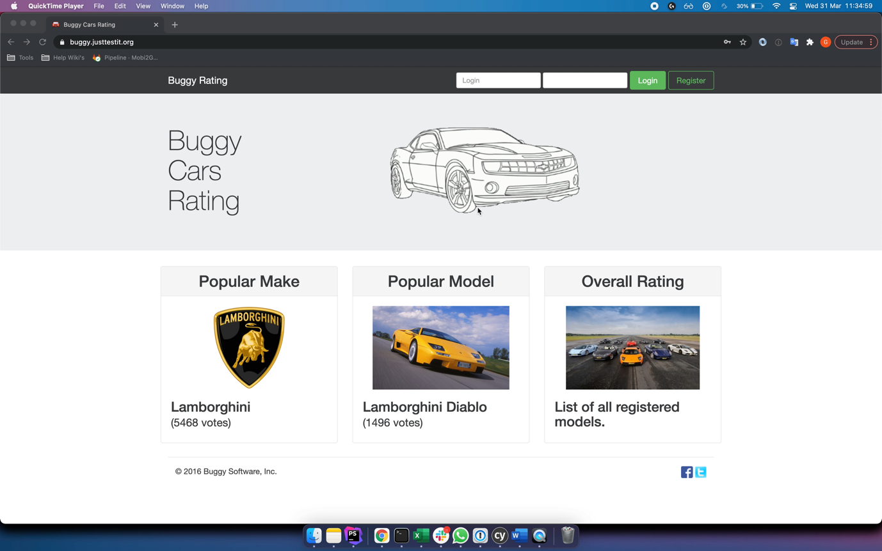Pagination_Issue.mov

Testing Details:

Platform: Macintosh Big Sur

Browser: Google Chrome v88.0.4324.192